

2020

Artificial intelligence

**Name:** Mostafa Abdallah Mostafa Mansour  
**Group:** 7

**Section:** 42  
**BN:** 23 **Seat number:** 924

**GitHub link:** <https://github.com/MostafaAMansour/html-project>

**GitHub (Published website):** <https://mostafaamansour.github.io/html-project/>

**Application brief:**

**A Website on Artificial intelligence (AI) and some applications that help disabled people.**

**Screenshots:**

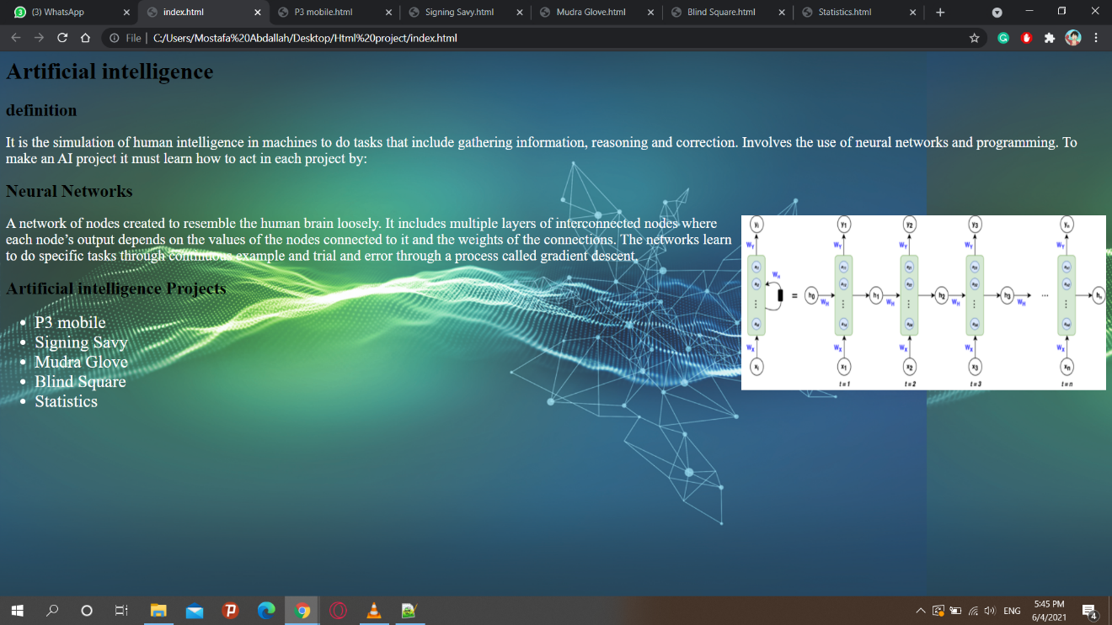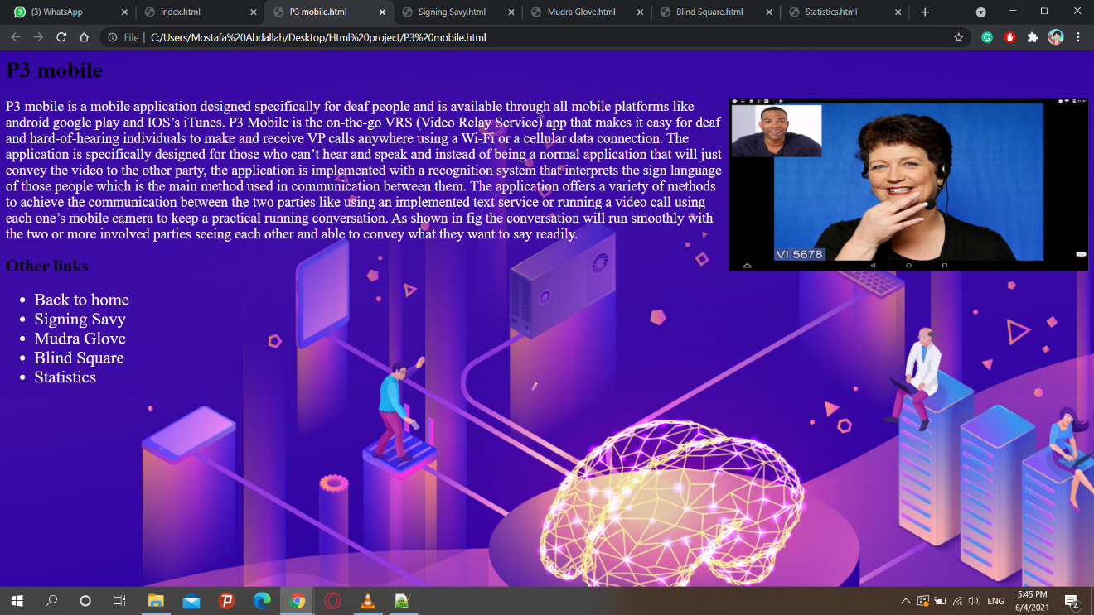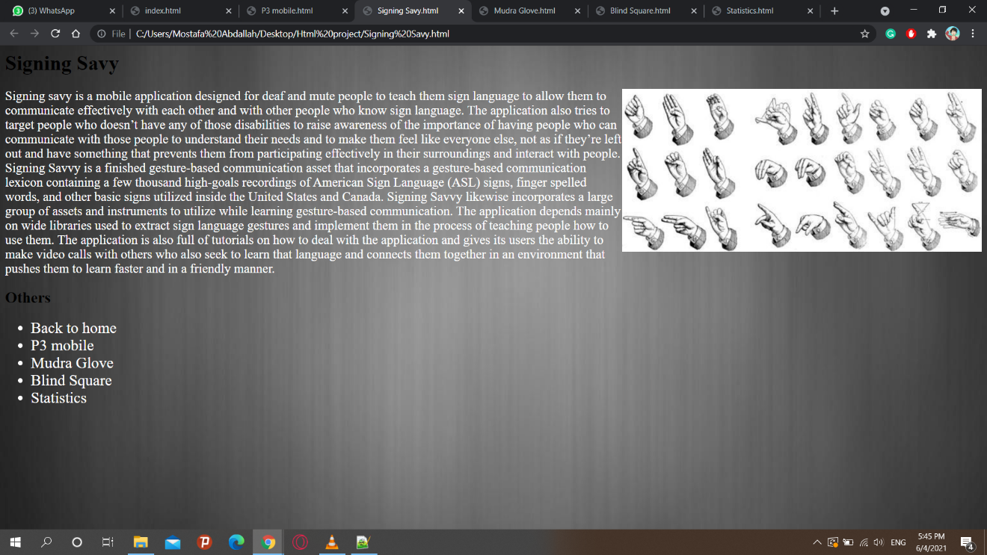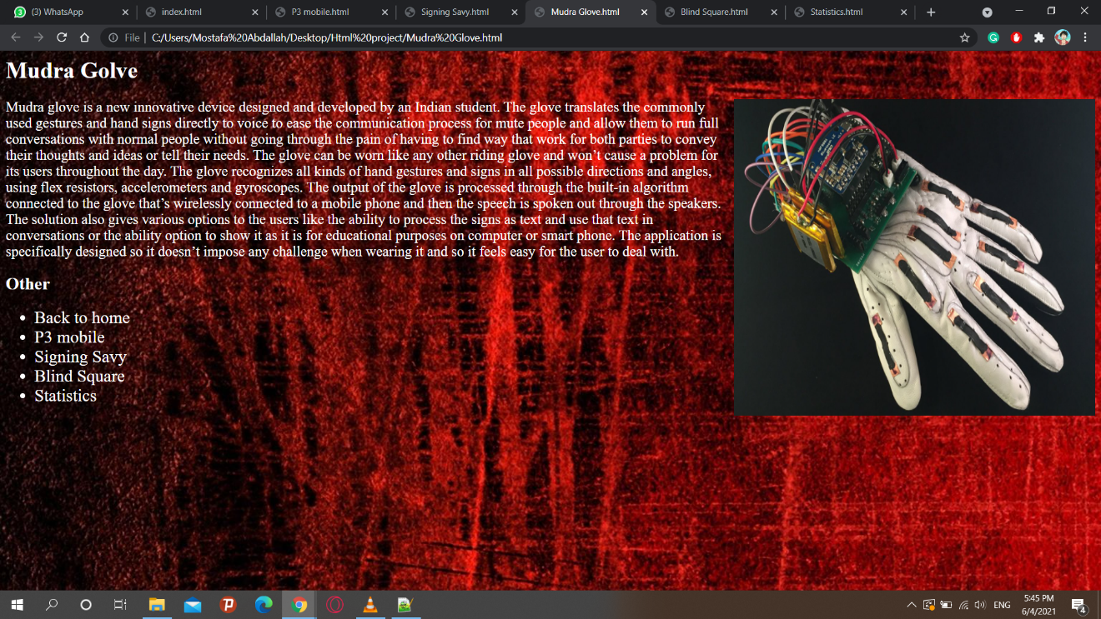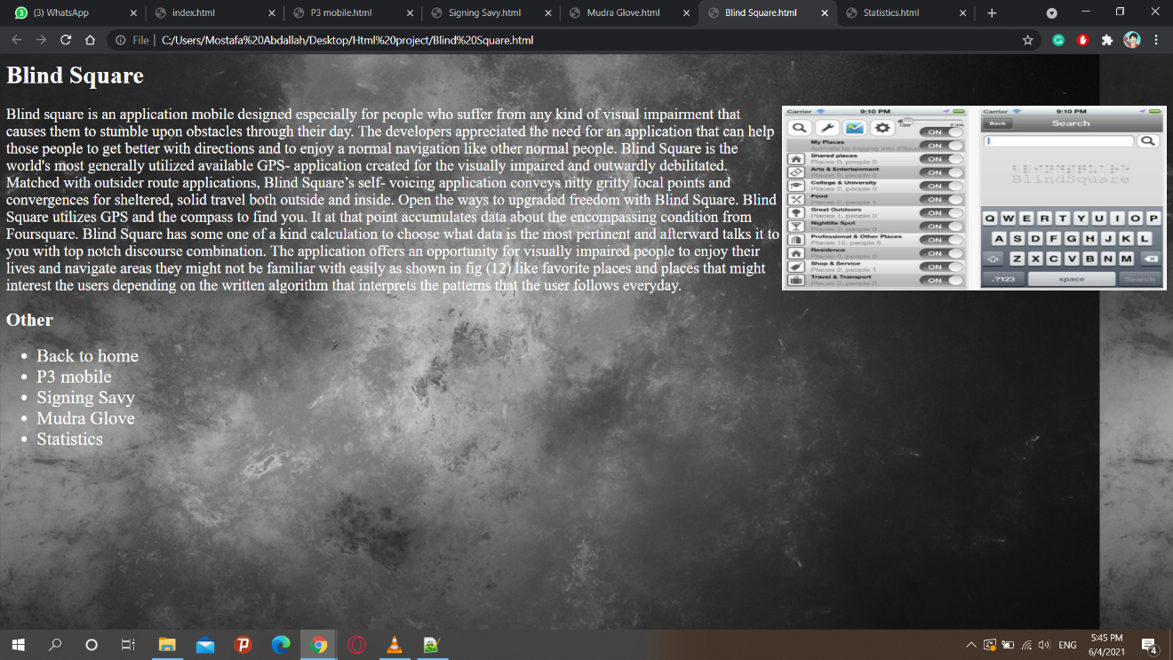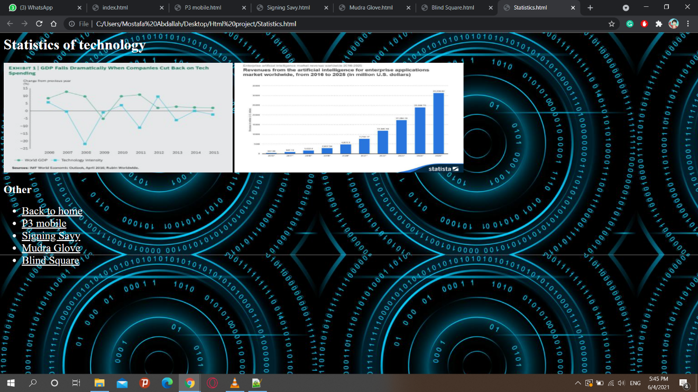

**Source code:**

